**Network Solution for Rest & Relax Pte Ltd**



Done by:

Lee Yi Terng (1904189)

Huang Caihong (1837861)

**Content**

1. Introduction 2

1.1 Purpose of Document 2

1.2 Factors Considered 2

1.3 Document Sections 2

2. Overview 3

2.1 Benefits of having a Network 3

2.1.1 Enhances communication and availability of information 3

2.1.2 Boost storage capacity 3

2.1.3 Inexpensive system 3

2.2 Suitable Internet Access Plan 4

3. Network Setup 5

3.1 Network Diagram and Layout 5

3.2 Network Topology, Protocols and Communications Media 6

3.2.1 Modem, Firewall, Internet 6

3.2.2 Routers 6

3.2.3 Switches, Access Points and Workstations 6

3.3 Software Recommendations 6

3.4 Hardware Recommendations 6

3.5 User Training 6

3.6 Future Expansion Plans and Network Scalability 7

3.7 Security Issues 8

4. Services 8

4.1 File and Print Services 8

4.2 Remote Access to Office Network 8

4.3 Data Backup 8

4.4 High Availability 9

4.5 Internet Access 9

4.6 Guest Internet Access 9

5. Conclusion 9

Individual Contribution 10

References 10

# 1. Introduction

## 1.1 Purpose of Document

This document is written to propose a network setup for Rest & Relax Designs Pte Ltd. The primary objective is to provide a detailed and well-versed description of the proposed setup.This document will help the owners of Rest & Relax Designs Pte Ltd make the best decision and advise accordingly for the network setup.

## 1.2 Factors Considered

This proposed network setup was created with the following factors considered:

* File and Print Services Required;
* Internet Access;
* Remote Access to Office Network;
* Data Security;
* The staff strength of ninety;
* Network Scalability;
* High Availability and Fault Tolerance.

## 1.3 Document Sections

Section 2: OVERVIEW

This section details the benefits of having a network in the company as well as the most suitable Internet Access Plan decided on for the proposed network setup.

Section 3: Network Setup

This section goes into details each aspect of the proposed network setup, some examples include but are not limited to Network Protocols, Hardware Recommendations and Software Recommendations

# 2. Overview

## 2.1 Benefits of having a Network

### 2.1.1 Enhances communication and availability of information

The network is like a window to the outside world remotely. It enables users to access vast amounts of information with just a few clicks or swipes of their fingers. With this, it has provided users with a wider horizon.

Additionally, this remote access to information functionality has also been boosted with speed. It allows instant messaging which provides real-time interaction with minimal to no delay which updates one of the outside worlds promptly. (Chief, 2015) For example, social media has become a platform for many to share information and stories of their lives. With this, traditional newspapers have definitely been replaced by online platforms of news providers.

Moreover, it also provides a platform for more convenient resource sharing. (Chief, 2015) Exchange of information can be done simply through the network. One can upload to share information and download copies of information.

Thus, the network provides a highly interactive platform which definitely has played a big part in widening one’s horizon.

### 2.1.2 Boost storage capacity

Without a network, resource limits might be one of the biggest issues. One of them is storage capacity. It requires hardware resources to save information or data. This can be a hassle as it can get very messy and costly. On top of these, it may not even be secured. Thus, the network is essential when it comes to this. With the network, it opens another door for the business as cloud storage will be available. (Chief, 2015) Cloud storage not only provides storage space, but there are also many more advantages. Some of them are as follows:

* Data redundancy and replication
* Regulatory compliance
* Ransomware or malware protection (Anon., 2018)

There are many advantages to using cloud storage. With this, the network is definitely essential in order to have access to it.

### 2.1.3 Inexpensive system

Installing networking would not cost too much given the long period of service it provides for other benefits. (Chief, 2015) There are also minimal updates to the services which ensure minimal inadaptability. Additionally, it also exposes users to many software products available on the market. These products might in turn help in the business progress, like storing customer’s personal data on a more secure platform. With these advantages, purchasing a network service is like an investment as it gives a more effective and efficient outcome in return. Thus, the network is definitely worth the investment.

## 2.2 Suitable Internet Access Plan

I would recommend signing up for an Internet Access Plan by an Internet Service Provider, M1. Its High-Speed Fibre and Security Bundle plan that costs SGD298 per month seems ideal for the company. This will ensure efficiency and effectiveness with the extra investment of fibre-optic-to-Ethernet converter box to allow fibre-optic cables to coexist with ethernet cables. (Hatter, 2020)

It has a speed of 1Gbps which is suitable for large file up and downloading, such as the sharing of internal graphic design. The company also potentially be using it for interactive web conferences and intense internet application use on top of the multiple devices per user. (HUNTLEY, 2017) Thus, 1Gbps will be able to cater to the heavy usage of the service.

Moreover, it is also able to assign eight static IP addresses. Static IP is an IP address that never changes. These IP addresses can be assigned to the company’s web server where there is a need for reliable name resolution on the network for computers to be consistently and accurately found. (FITZPATRICK, 2017) The extra availability will then allow future expansion.

Additionally, it also includes many other attractive services. For example, router and installation, 24/7 technical helpdesk. On top of these, it also has enhanced security features. One of the features is that it is Palo Alto Networks Powered. It is an American multinational cybersecurity company that provides advanced firewalls and cloud-based offerings that extend those firewalls to cover other aspects of security. This might seem very technical but the security is fully managed by M1 to provide the services and come out with monthly reports to the customer. Thus, it requires minimal worries for the technical support in the company as it has been configured and managed properly by the Internet Service Provider.

# 3. Network Setup

## 3.1 Network Diagram and Layout

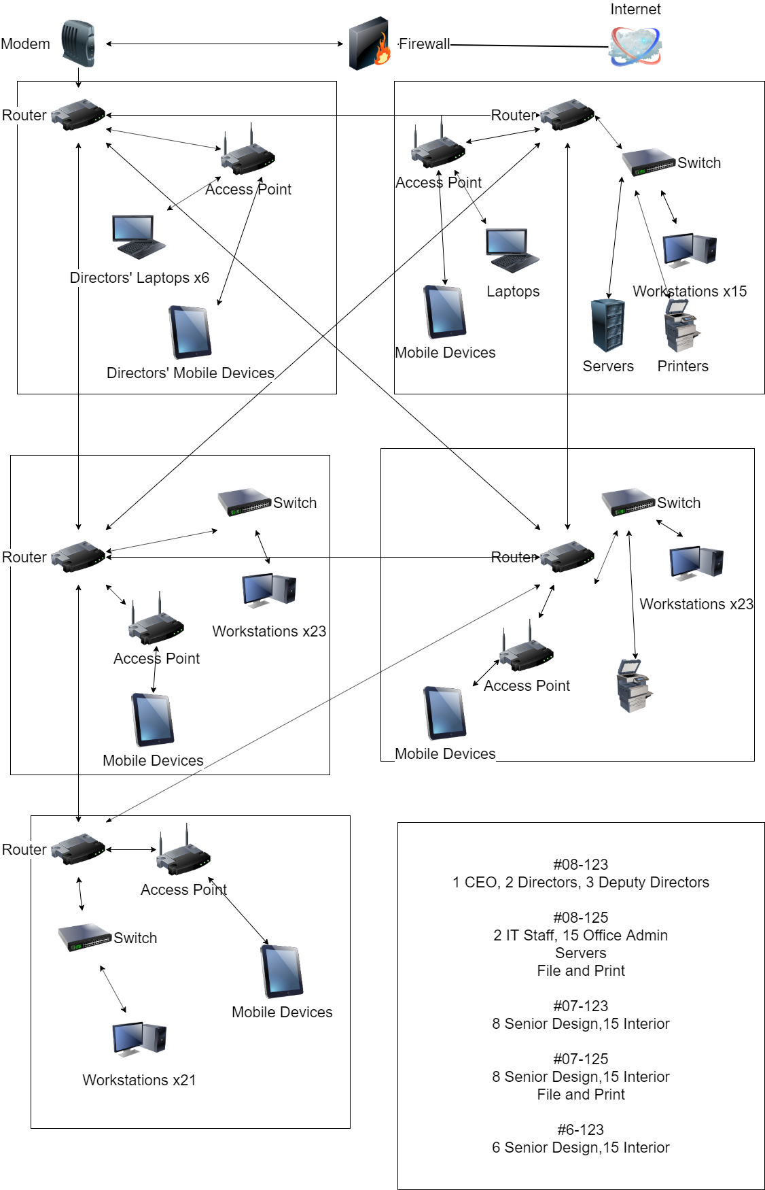

## 3.2 Network Topology, Protocols and Communications Media

### 3.2.1 Modem, Firewall, Internet

#08-123 will be used as a demarcation point. The router in #08-123 will be used as the network gateway connected to a modem. The modem is then connected to the main Internet to allow for Internet access. A firewall protects the local network from outside threats. The network will be using TCP/IP.

### 3.2.2 Routers

The routers are connected in a partial mesh to ensure high redundancy. Each router is connected to two or more other routers to ensure there is always a path for data to travel should any router go down. The routers will be connected to each other using fibre optic backbone cabling to ensure high speeds of data transmission.

For routing protocol, Enhanced Interior Gateway Routing Protocol (EIGRP) will be used. It is a hybrid distance-vector protocol that supports scalability and quick convergence times. It is the best choice for a routing protocol on private networks because it offers the best balance between speed, scalability and ease of management.

### 3.2.3 Switches, Access Points and Workstations

Ethernet cables will be used to connect the routers with switches and access points. Workstations, printers and servers will connect to the switches using Ethernet cables, while mobile devices such as laptops, handphones and tablets will connect to the Access Point using IEEE 802.11n. This standard was chosen due to the ability to use 2.4GHz as well as 5GHz, to reduce interference from other devices using 2.4GHz. It also supports high bandwidth at about 600Mbps, which will be sufficient to ensure high speeds for mobile devices.

## 3.3 Software Recommendations

Microsoft Windows Operating Systems to be used on all workstations. Server management software as well as AWS Cloud for backup. Anti-virus and firewalls to be installed to provide security against malicious threats.

## 3.4 Hardware Recommendations

Five routers, five access points, four switches, 1 modem and one server room and two printing rooms.

## 3.5 User Training

User training is important as safe internet habits can greatly help to minimise the risks and damage caused by improper end-user training. With this, training is critically important to organisational success and development. Thus, this training should be done by a knowledgeable professional who has the company’s best interests in mind.

IT security professionals are well-rounded. Ensuring the security of the network requires a high degree of IT experience and knowledge, regardless if it is hardware, software, application or programming. Moreover, not all IT professionals are IT, security specialists. However, all IT security professionals are well-rounded IT specialists. Thus, IT security professionals can be trusted to provide excellent end-user training. Thus, it is important to select the right trainer for the company’s user training properly as it has the potential to cause huge harm as the vulnerability increases with every mistake made. (Anon., 2016)

Thus, a professional third party should be engaged to provide this user training for the company. One of the companies that provide such service in Singapore is NobleProg. Some of the information covered during the training should include the following:

* Clean Desk Policy
* Bring-Your-Own-Device (BYOD) Policy
* Data Management
* Removable Media
* Safe Internet Habits
* Physical Security and Environmental Controls
* Network monitoring
* Business continuity plan (Imam, 2020)

These are important topics to be passed to the user to ensure the best interest of the company. With this knowledge, it reduces the risks the company might be facing due to the lack of consciousness of the use of the network. Thus, having a third party to provide the user training will be of the company’s best advantage due to its coverage.

## 3.6 Future Expansion Plans and Network Scalability

The proposed network setup has also taken future expansion plans and network scalability into consideration as the company develops in the future.

We have implemented many routers and access points. It not only covers a larger physical area but also has the potential to hold up to 250 connected devices at a time. (Mitchell, 2020)

Moreover, there are also many switches installed. Switches work at the Data Link layer where it receives frames on one port and forwards it to the port where the destination device can be found. Given this, it can also send broadcast frames out to all ports in the LAN. With this, an advanced switch feature is that it allows Virtual Local Area Networks (VLANs). VLANs enable one to configure one or more switch ports into separate broadcast domains. This would mean that it allows administrators to group users and resources logically instead of by physical location. For example, if an employee has a change of department or role in the company, there is no need to change the location of his working desk or do rewiring so that he could access the information he requires. The administrator can simply configure the port in the switch to include him into the VLAN. With this, there is improved management and security of the network and gives more control of broadcast frames.

Last but not least, for future expansion, the company may also choose to engage another Internet Service Provider (ISP), such as Singtel or Starhub, for fault tolerance. This would ensure business continuity when the service by M1 is down. This is so as there is another ISP for the company to tap on when one fails. Additionally, with another ISP, it can also serve a bigger group of people when the company expands. It does not need to serve as a backup plan sorely. With this, there is improved effectiveness and cost-efficiency.

## 3.7 Security Issues

Network security is of utmost importance, and it is crucial to ensure only authorised personnel should be able to access the network. In addition to User Training (Section 3.5), the wireless network is hence protected with Wi-Fi Protected Access 2 (WPA2) to ensure adequate protection and security. The password chosen would also have to be strong, with a combination of characters not in sequence or a particular pattern.

Employees should also refrain from setting up their own access points without permission or guidance from the IP staff. This is to prevent the possibility of creating a rogue access point which attackers can exploit to access the network.

# 4. Services

## 4.1 File and Print Services

The staff of the company will have access to file systems on their servers. As the server is connected to the local network, designers can store and access their work and others work through their workstations. An alternative is to connect using a mobile device such as a laptop as well to access the file systems in the server.

Print services are also available on floor 7 and 8, in #07-125 and #08-125 respectively. Staff can send their print requests through their devices that are connected to the local network from whichever room there are in and then proceed to their printer of choice to collect. Having two printers also ensures high availability and reduced chances of congestion or overloading.

## 4.2 Remote Access to Office Network

It is understood that the CEO, directors and designers need to access their work from home to ensure high productivity and efficiency. This can be done by using a Virtual Private Network (VPN).

Using the hardware specified above, specifically routers, with proper configuration of the router and a static IP address for the network, the staff can use their home computers to access the office network remotely. This can be done on both Windows and Macintosh devices with VPN.

Alternatively, another solution is to use a free service called LogMeIn, LogMeIn allows you to remotely control your computer in the office from any computer that has a web browser, or even from an iPhone. Setup is very simple and takes a matter of minutes.

## 4.3 Data Backup

Data on the local physical servers will be backed up to the AWS Cloud. This helps save costs as it can be very expensive to set up another physical server for local backups. Furthermore, with a third-party cloud service provider handling the backups, the company can focus more on pleasing their clients and the business side of things.

## 4.4 High Availability

The routers are connected in a partial mesh topology to allow high redundancy and not cause a breakdown in the network should a router go down.

In most rooms, there is an access point and switch. Should the switch go down, the workstations can then connect to the access point to ensure continued connectivity to the local network.

It is also good to always have backup hardware such as routers, switches, access points and cables at hand to ensure minimal downtime should any of these devices become faulty.

## 4.5 Internet Access

Staff in the office will have internet access when connected to the local network. This is essential for research, communication and many other purposes. The firewall in between the modem and outside network also helps protect the internal local network from outside harm. The modem also provides the local network with a connection to the Internet.

## 4.6 Guest Internet Access

An additional access point can be set up in the CEO office in #08-123. This is to provide guests and clients there for meetings with a guest network to connect to that provides complimentary Internet Access. This guest network should not have access to any resources in the local network and should only be used solely to provide guests with complimentary Internet service.

# 5. Conclusion

In conclusion, network practicality and security play an important role in business progress. This is so as it is crucial to ensure the smooth operation of the business. It is of the business best interest with proper implementation and usage of the network as it is the first preventive measure to the dangers from cyberspace. With this, we have taken the business best interest into consideration and proposed the above network setup and usage that would benefit the company in the long run.

*End of Report*

## Individual Contribution

Lee Yi Terng – Section 1, 3 and 4

Cai Hong – Section 2 and 5

## References

office, H. (2020). *Connect to Your Work Network Remotely - Resolve*. [online] Resolve.co.uk. Available at: https://resolve.co.uk/blog/article/how-to-connect-to-your-work-network-from-outside-the-office [Accessed 31 Jan. 2020].

Sumac Non-profit Software. (2020). *How to Setup a VPN to Access Your Office Files Remotely - Sumac Non-profit Software*. [online] Available at: https://www.sumac.com/how-to-setup-a-vpn-to-access-your-office-files-remotely/ [Accessed 31 Jan. 2020].

Anon., 2016. *SecurityRI.com.* [Online] Available at: <https://www.securityri.com/end-user-training/> [Accessed 13 Feb 2020].

Anon., 2018. *Channel Futures.* [Online] Available at: <https://www.channelfutures.com/from-the-industry/5-benefits-and-3-drawbacks-of-using-cloud-storage-for-your-baas-offering> [Accessed 13 Feb 2020].

Chief, 2015. *Green Garage.* [Online] Available at: <https://greengarageblog.org/14-main-advantages-and-disadvantages-of-computer-networking> [Accessed 13 Feb 2020].

FITZPATRICK, J., 2017. *How-To Geek.* [Online] Available at: <https://www.howtogeek.com/184310/ask-htg-should-i-be-setting-static-ip-addresses-on-my-router/> [Accessed 13 Feb 2020].

Hatter, D., 2020. *Chron.* [Online] Available at: <https://smallbusiness.chron.com/recommended-way-connect-fiber-optic-line-ethernet-switch-60200.html> [Accessed 13 Feb 2020].

HUNTLEY, M., 2017. *MDSi.* [Online] Available at: <https://www.mdsiinc.com/company/news/business-and-bandwidth-how-much-do-you-actually-need/> [Accessed 13 Feb 2020].

Imam, F., 2020. *INFOSEC.* [Online] Available at: <https://resources.infosecinstitute.com/top-10-security-awareness-training-topics-for-your-employees/#gref> [Accessed 13 Feb 2020].

Mitchell, B., 2020. *lifewire.* [Online] Available at: <https://www.lifewire.com/how-many-devices-can-share-a-wifi-network-818298> [Accessed 13 Feb 2020].

## 

## 